Washington Premier League (WPL) Rules

NOTE: These rules are updated 01/04/2023 and in effect for 2022-2023 league play for all WPL.
General Governance
Rule 101--Board
The league’s board is governed by the WPL bylaws.
Rule 102 --Territories
No club has exclusive territory rights in the WPL
Rule 103 -- Conditions for Removal of a Team or Club
Violation of performance conditions set forth by the league may lead to removal of a team or club from the WPL.
Rule 104 -- Conditions for Competition in Leagues
Following each season, the competition committee shall review the compliance record of each team in their specific division. The committee may find that compliance with the standards is insufficient and recommend action to the league office. In extreme cases of repeated non-compliance the respective executive committee may recommend the removal of the team or club in question.
Rule 105 -- Conditions for Team Acceptance into League
Any club in good standing with US Club Soccer may apply for acceptance into our current leagues. Priority will be given to teams that are part of clubs that commit most of their teams to participate in WPL leagues. Please note that each league may have additional requirements. Please check the specific league descriptions and standards on our website for additional information. Team placement is based on competition and location.
Rule 106 – Requirements for NPL Super League Clubs
Please see Super League Standards & Policies. Acceptance into the Super League is determined by the League and by the standards and policies set by the Super League Advisory Committee.
League Structure
Rule 201 -- Governance
All competition in the WPL are governed by regulations approved by the league office.
Rule 202 -- Division Formations and League Standards
Competitive divisions will be structured according to the competitive level of teams as determined by the League Director, who has final authority on all placement issues. Should the WPL determine that there are an insufficient number of teams to constitute an age group division the teams affected may be allowed to temporarily or partially compete in a different division of play. Additionally, if there are an overabundance of teams in an age group, teams may be grouped differently than requested. Clubs must also request "in writing" any teams who are intending to "play up". The WPL must approve these requests. The League has the authority to arrange teams to fit the needs for one or more of the following: scheduling, travel, competitive levels or other exceptions. All NPL Super League teams must follow special league standards and policies for Super League clubs.

Rule 203 -- Playing Rules
All games under league jurisdiction shall be played according to the rules and regulations recognized by the WPL which shall be the same rules set by FIFA/ U.S. Soccer (USSF) except for those modifications authorized by the WPL, FIFA or USSF.
Rule 204 -- Playing Season
The “League” is designated by the WPL for the season in which the league is played. Example, spring, summer, fall or winter, but shall not be limited or restricted to a season.
All league games must be played on or by the last day games are scheduled by the league for the current season. No games will be played after that date unless approved by the League. If prior to the original scheduled game date teams are not able agree to a reschedule, the league office must be notified to arbitrate, or the match is played as originally scheduled.
Any games not played by the last day of the league season may be scored as a loss for both teams and a minimum fine of $1500 assessed to both teams. Please contact the league immediately if a scheduling issue arises that cannot be resolved. If fines are assessed, Clubs have 10 days to pay the fine. Clubs will not be able to register teams for Cup or League play until the fine is paid.
Note: At League registration: all NPL Super League teams are required to pre-register to play in Washington Cup (end of the season State Championship tournament).
Rule 205 -- Point System
The WPL shall operate under a point system. The point system shall award three points for a win, one point for a tie and no points for a loss.
In the event where an unequal number of games have been played by teams within a division due to a schedule change driven by the league, the final standings will be determined by average points per match played.
All Forfeits will be scored by league office as 1-0. (see Rule 307A)
For tie breakers these rules will apply in the order they are listed here:
1) Total Points (win/lose/draw) between teams
2) Total Goals Against
3) Total Goal differential of each team (Total Goals for, minus Total Goals against)
4) Total Goals for (maximum of 5 goals per match allowed, except in the Super League Divisions where all goals scored are counted)
5) In the event all tiebreakers are equal, the winner shall be decided by coin toss.
6) If 3 or more teams are tied, the tiebreaker criteria listed will be used in order above to first eliminate or second promote one team. Teams remaining will then be compared again starting with first tiebreaker.
For Developmental Leagues, match scores will be posted in the League standings with a maximum 5 goal difference between Dev teams.
Rule 206 -- League Standings
Official standings of teams, which is the responsibility of the league office, are tabulated on a regular basis, and displayed on the Washington Premier League website. For score reporting see Rule 306

Rule 207 -- Playing Venue, Game Lengths, USSF mandates
The playing field used by each team must be lined according to FIFA standards with goals nets and flags. Teams in NPL Super league may have additional expectations per standards set for teams in those divisions.
Home teams are responsible for marking the field of play, providing an adequate game ball (modified as follows):

Age¹ | Format | Game Duration | Ball Size | Field Size Mandate width x length | Field Size Range width x length | Goal Size (height x width)
7U# | 4v4 | 4 x 10 min quarters, 3 min breaks | 3 | 20 yds x 30 yds | 15-25 yds wide x 25 – 35 yds long | 4' x 6'  Pugg Style goal
8U# | 4v4 | 4 x 10 min quarters, 3 min breaks | 3 | 20 yds x 30 yds | 15-25 yds wide x 25 – 35 yds long | 4' x 6'  Pugg Style goal
9U# | 7v7 | 2 x 25 min halves, 5 min halftime | 4 | 40 yds x 60 yds | 35-45 yds wide to 55-65 yds long | 6’.6” x 18’.6” ideal 6' x 18' and portable style acceptable²
10U# | 7v7 | 2 x 25 min halves, 5 min halftime | 4 | 40 yds x 60 yds | 35-45 yds wide to 55-65 yds long | 6’.6” x 18’.6” ideal 6' x 18' and portable style acceptable²
11U# | 9v9 | 2 x 30 min halves, 5 min halftime | 4 | 50 yds x 75 yds | 45-55 yds wide to 70-80 yds long | 7’ x 21' ideal 6’.6” x 18’.6” and portable style acceptable²
12U# | 9v9 | 2 x 30 min halves, 5 min halftime | 4 | 50 yds x 75 yds | 45-55 yds wide to 70-80 yds long | 7’ x 21' ideal 6’.6” x 18’.6” and portable style acceptable²
13U# | 11v11 | 2 x 35 min halves, 5 min halftime | 5 | 75 yds x 112 yds | 60-80 yds wide to 100- 130 yds long | 8' x 24'
14U | 11V11 | 2 x 35 min halves, 5 min halftime | 5 | 75 yds x 112 yds | 60-80 yds wide to 100- 130 yds long | 8' x 24'
15U | 11V11 | 2 x 40 min halves, 5 min halftime | 5 | 75 yds x 112 yds | 60-80 yds wide to 100- 130 yds long | 8' x24'
16U | 11V11 | 2 x 40 min halves, 5 min halftime | 5 | 75 yds x 112 yds | 60-80 yds wide to 100- 130 yds long | 8'x 24'
17U | 11V11 | 2 x 45 min halves, 5 min halftime | 5 | 75 yds x 112 yds | 60-80 yds wide to 100- 130 yds long | 8' x 24'
18U | 11V11 | 2 x 45 min halves, 5 min halftime | 5 | 75 yds x 112 yds | 60-80 yds wide to 100- 130 yds long | 8'x 24'
18U | 11V11 | 2 x 45 min halves, 5 min halftime | 5 | 75 yds x 112 yds | 60-80 yds wide to 100- 130 yds long | 8' x 24'
¹Refer to WPL current Birth year Chart
²BowNet, # SKLZ style goals are only allowed at 7v7 (8U/10U) and 9v9 (11U/12U) for all division except NPL Super League

Rule 207A- US Soccer Small-sided Mandates
Modified Soccer (10U-8U) – Rules and Procedures
Small sided application of USSF Guidelines
10U - 8U (7v7)
- Game Duration – 2 x 25 min halves, 5 min break
- 7 v 7- including goalkeepers
- Build out line / Off-side line will be used (equidistant from Penalty Area to Halfway line)
- Goal Keepers will not “punt” or ‘drop kick’ the ball. They may distribute via throw, pass or roll on the ground after opponents retreat behind the build out line. If they choose to play prior to players retreating behind the line there is no infraction of the rule. After the ball is put into play, the opposing team can then cross the build out line and play can resume as normal. Goal Kicks require players to retreat behind the build out line prior to the kick being taken.
Note: The ball is “in play” once it is kicked If opposition team crosses the build out line prior to this the kick is retaken.
Off-sides will be called. The build out line will be used in determination of off-sides vs using the center line. Players between center line and build out line are not to be considered as off-side.
- Direct free kicks will be called
- No intentional heading ( indirect free kick if determined to be intentional)
- Goal sizes- 6.5’ x 18.5’ (6’ x 18’ allowed)
- Portable goals must be secured (eg. Sandbags or staked-down to ensure player safety at all times)

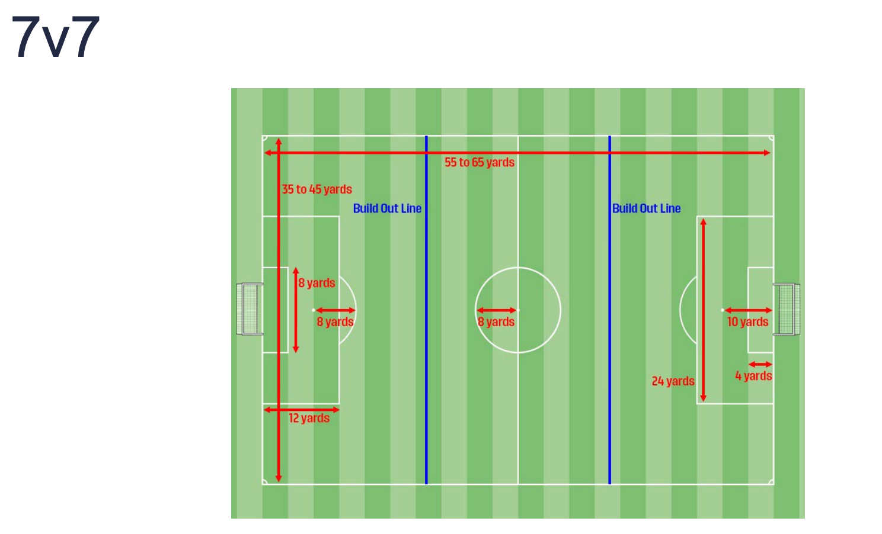

11U/12U (9V9)
- 9v9 (8 field players and 1 goalkeeper)
- Substitutions are unlimited and can occur at any stoppage
- NO Build out line
- Offsides will be called (center line used as off-sides line
- Goalkeepers may punt or drop kick the ball
- Goal sizes- 6.5’ x 18.5’ (6’ x 18’ allowed)
- Portable goals must be secured (eg. Sandbags or staked-down to ensure player safety at all times)

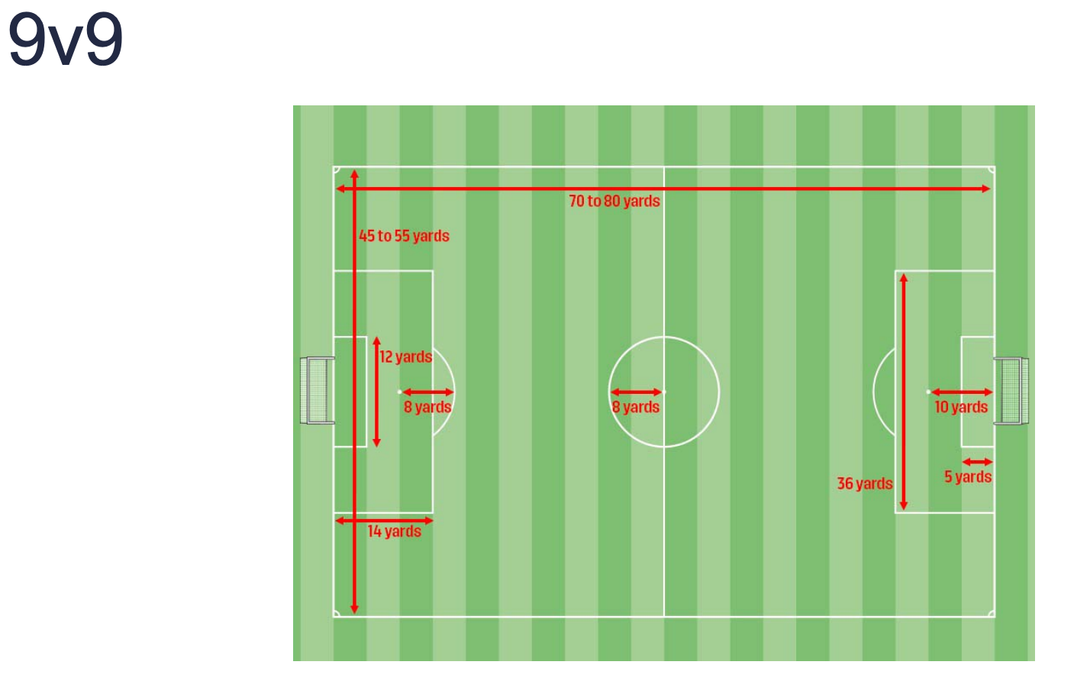

Rule 208 – Heading Game Rule
USSF Heading Mandate - All WPL and NSRL leagues have adopted the USSF Heading mandates. For 11U and under leagues players may NOT engage in heading in either games or practices. Limited heading in practice for players in 12U and 13U ages of 30 min maximum per week.
Referees are instructed for all 11U and under games to apply the following rule:
When a player deliberately heads the ball in a game, an indirect free kick (IFK) should be awarded to the opposing team from the spot of the offense. If the deliberate header occurs within the goal area, the indirect free kick should be taken on the goal area line parallel to the goal line at the point nearest to where the infringement occurred.
A. No Re-Entry Protocol (for Head Injury)
In accordance with the US Soccer return to play guidelines, any player removed from the field for a suspected head injury will not be allowed to return to the field of play unless cleared by a Healthcare Professional.
B. Health Care Professional
A health care professional is defined as “a licensed healthcare professional such as an athletic trainer certified (ATC), or a physician (MD/DO), with a skill set in emergency care and sports medicine injuries and with knowledge and experience related to concussion evaluation and management.” It will be up to each club to decide whether they will provide a healthcare professional at their matches, and to ensure that this individual has the correct certification to be evaluating players for head trauma. If a club plans to use a healthcare professional to evaluate suspected head injuries during a WPL/PSRL match, the healthcare professional must be presented to the referee prior to the start of the match. Referees will not allow the re-entry of players removed from the field of play for suspected head injuries unless they are informed of the presence of, and meet with, a healthcare professional prior to the start of the match.

Rule 209 -- Rosters
· All teams may list up to 26 players on their US Club Official Roster.
· Players can be only rostered to one team that is affiliated with US Club Soccer and the WPL.
· As a requirement to register a valid team for a WPL league, each team must follow the minimum roster sizes listed below and have their Official US Club Roster updated in GotSport for the League office to review approximately 20 days before the start of league play.
· For match days, the WPL Match Day Roster has limits to the number of players that can be listed.
See Chart Below:
Roster Size Chart
 | Number of Players
Age | Min. to register team | Game Day Roster max.
7U/8U | 5 | 8
8U/10U | 8 | 14
11U/12U | 10 | 16
13U/18U | 13 | 18
15U trapped | 11 | 18

Note: WPL Match Day Roster must be generated from Gotsport.

Rule 210 -- Scheduling
A. Scheduling is a major issue each season. The commitment to play matches when scheduled is a priority, as field availability is limited. All matches scheduled by the WPL are expected to be played on the date scheduled.
B. If a Club/Team has special scheduling requests, the requests must be submitted via the schedule request web form. These requests must be received by the registration deadline for the specific league/season. Schedule requests must be limited to no more than two (2) requests (see form) per team.
C. The WPL schedulers do their best to honor scheduling requests submitted by the deadline but cannot guarantee that all requests will be honored. Please prioritize your requests.
D. In the event the posted schedule cannot be met, please refer to Rule 211.
E. Teams unwilling or unable to attend a match will forfeit points from the unattended match. Please see Rule 307A for more information on forfeits.
F. The WPL will work to schedule certain “black-out” dates to allow players to participate in sanctioned WPL Surf Academy Events and Trainings.
G. The WPL Western Dev. leagues (8U – 10U) will be scheduled through the WPL office. Teams will play on Saturday and/or Sunday based on field availability across multiple locations.
210A -- Team Scheduling (times and locations)
A. Please post-match times and locations as soon as known as a courtesy to all impacted.
B. The home team is responsible for posting the time and location of the match no later than 72 hours prior to the match.
Exception: for matches involving teams traveling over 3 hours or involving a doubleheader weekend, the home team must post the match time and location no later than 6:00pm on the Sunday
prior to the scheduled date of the match to allow visiting teams and opportunity to make overnight travel arrangements.
-Posted contact information for both Coach and manager must be kept current on the WPL team site. It is the responsibility of the home team to inform the visiting team of any changes that may occur.
210B-- Travel Time Scheduling Windows for Single Match and Doubleheader Weekends
The attached grid is designed to help eliminate some of the conflict when extended travel is a factor. The expectation from the WPL is for Home Team Clubs to prioritize matches involving visiting teams with extended travel. The grid is used as a guide.
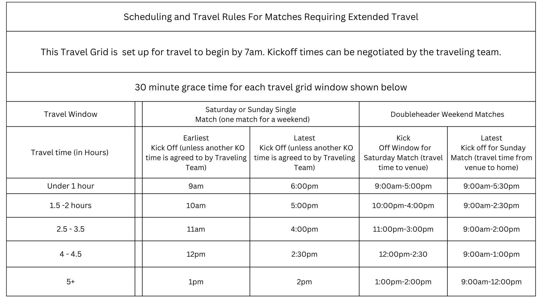
Single Match Weekend
The Travel grid simplifies home clubs' "window" for scheduling visiting teams who are only playing a single match in a weekend.
Doubleheader Weekend
The Doubleheader "scheduling windows" have some flexibility for the visiting teams. Communication between Clubs is essential for matches to be scheduled effectively. Saturday matches must be scheduled with the travel to the venue a priority. For scheduling Sunday matches, the Saturday Home Club must consider any travel between their venue and the Sunday match. The Sunday Home Club must confer with the visiting team to make sure the visiting team can return home in a reasonable time. Visiting teams have the right to negotiate with home teams if for some reason they want to "kick off" earlier or later than the grid allows for.
The WPL reserves the right to approve the double-header schedules in case of disputes between both parties. Please be forewarned: to maximize the competition and minimize travel, there will be very little flexibility for home teams hosting traveling teams, particularly traveling across the Cascades. This applies to all NPL Super League teams but may also apply in to other WPL divisions when appropriate.
Rule 211 -- Rescheduling Matches
A. Matches may be rescheduled without the approval of the league unless it involves a double header weekend (see Rule 210C). Please be aware that Rule 204 applies here too, and Clubs can incur fines and forfeits if the matches are not played.
B. Once schedules are published, matches may not be moved to a different date/time without the express written approval of the opponent.
C. Clubs/Teams are not obligated to agree to reschedule matches.
D. All matches that are being negotiated for rescheduling, must be agreed to, and posted on the WPL website no later than 16 days from the first day of each league season. Rescheduling matches will not be allowed after the 16th day of the season (with the exception of inclement conditions out of teams’ control).
E. After the 16th day of the season, all matches must be played on the date posted. Clubs may request arbitration from the League Director up to the 10th day of the season. All League arbitrated decisions are final. Any Club/team with more than 2 occurrences of matches not played because of rescheduling issues could also face forfeits, suspension, additional fines or expulsion of the team(s) involved. At the conclusion of the season, matches not played because of scheduling issues will be counted as “no contest” in the final standings (if deemed so by the WPL).
F. Matches can be rescheduled without the approval of the league unless it involves a double header weekend (see Rule 210C). Please be aware that Rule 204 applies here too, and Clubs can incur fines and forfeits if the matches are not played.
G. Once schedules are published, matches may not be moved to a different date/time without the express written approval of the opponent.
H. All charges related to fields and Referees are borne by the home team unless alternate arrangements have been made with visiting team.
I. In the event a match is not played for any other reason not addressed in the rules, the league must be notified within 24 hours of the scheduled time by both teams.
Rule 212 -- Uniforms
All teams must post their jersey colors on their team page or the home team must contact the visiting team no less than 72 hours prior to the match, to confirm jersey colors.
· In the event of a jersey color conflict, the home team is required to wear or change to an alternate color. Every player must have a unique number on their jersey. A minimum size of 6” tall on the back of the jersey.
· For NPL Super League teams only, taping or altering of jersey numbers is prohibited. Players without a proper jersey will not be allowed to play, unless authorized prior to the match by the WPL.

Registration and Game Day Procedures
Rule 300-- Team Management Requirements
· Each team must list a team manager, coach and supply contact information including current email addresses and phone numbers. The listed phones and emails must be checked daily and be updated in the contact information in the event of a change.
· The Team Manager and/or Coach are responsible for responding to all communications regarding teams, league business, reporting scores and all communications to the appropriate league officials. All teams must have access to email, and a telephone number connected to a 24 hour answering system during the season. All teams are responsible for maintaining their contact information in GotSport system.
Rule 301-- Eligibility: Official US Club Rosters and Player cards
A. Official US Club Rosters and Player cards
· Players, coaches, and managers must be registered according to US Club rules.
· All players must be listed with complete information including jersey number. Changes may be made to the roster during the season. All changes are tracked by the WPL. Players not listed on the US Club Roster most currently entered in GotSport are considered illegal and will constitute a forfeit for the team. Any player permanently moved to another team within the club procedure must be done by 6pm the Friday before the scheduled match the player(s) in question may play in.
B. US Club Player/Coach/Staff Identification Card
- All Players, Coaches and Staff must present their valid US Club Player/Coach/Staff Identification Card to the referee prior to the match. The individual’s picture must be lamented on the card. Club officials (Coaches, Managers, DOC’s) are required to visibly display their card on a lanyard while in the technical area (max. of 4 team officials in area).
- Any individual participating in the match will not be eligible for the match if the ID card is not valid, and the player is not listed on the Match Day roster/US Club official roster. No exceptions.
- For updated Match Day procedures, go to Resources tab on our website then click on Manager’s Corner and then click on Forms & Policies and then Match Day Procedures or Click Here for a direct link
- Any team not following WPL match day procedures will be subject to fines, forfeits and/or further sanctions.
C. Players may only play for one US Club Soccer club during any league season. Guest players are not allowed in league play. (A Guest player is any player not currently rostered to your club).
D. WPL leagues from 8U through 18U are defined as either boys’ or girls’ leagues. In the WPL, players must play on teams of their same sex. * Please see the GENDER POLICIES for exceptions: CLICK HERE
E. Players may change clubs at any point in the season as long as they adhere to the WPL and US Club transfer policy. Players requesting transfer between two clubs must complete the following prior to be eligible to play:
- Serve a seven-day waiting period from the time an updated league roster is received by the League Office showing the player has a valid US Club player card.
- Have their US Club Player Card released from former club or is approved by the Competition Committee.
- Have met all financial obligations agreed to with their former Club.
F. All players registered with a Club participating in the WPL shall receive a US Club Soccer player ID card which shall allow a player to play on any team within that club with the following exceptions:
- Players can only play at their age or "play up".
- Players must adhere to Rule 302 “Club Pass”
Please note:
- Younger players can "play up" in age if the club determines they are capable. To be eligible to play up, players must be rostered on the US Club Official roster for the older team or rostered on an "on age team’s roster within the club. Players can only be rostered on one team in their club. Eligibility is determined by the player’s name being listed on the US Club Official roster from same club with a valid US Club ID number. Reminder: Super League roster rules may apply.
- Teams/Clubs violating this rule will be put "on notice" by the league, face sanctions, fines and possibly expulsion from the league.
- Exceptions to Age and Gender rules may be considered. Please see the "Exception Form" on WPL website.
Rule 302 - Club Pass (formerly known as the “Player Pass”)
The intent of the "Club Pass" rule is to provide a tool for coaches to give players an opportunity to play at a level that is developmentally appropriate for the player and to provide a way of getting more minutes for players needing them. The "Club Pass" is not to be used unethically.
· Each team may use the “Club Pass” for a maximum of 4 players for 7v7, 5 players for 9v9 & 11v11 in a single match. These Club Pass players must be noted on the WPL Match Day Roster along with providing the copy of the Official US Club roster(s) these players are rostered to.
· Violation of the "Club Pass" rule will constitute one or all the following, a fine, forfeiture of all matches these players played in, suspension of the offended coach and sanctions against the Club involved.
“Club Pass” Restrictions
· All “on age” rostered NPL Super League players are eligible only to be “Club Passed” on age to NPL Super League divisions. NPL Super League players are allowed to “pass up” to all divisions excluding one year older in the Copa divisions. All eligible WPL Classic and Copa players may be “Club Passed” to older ages.
· NPL Super League Players that are rostered “play up” (playing on older age group team) may NOT play “on age” at any level of play.
· All Classic division players are unrestricted beyond adhering to age, gender, and Club Pass limit requirements.

There are no Club Pass restrictions for the WPL Development leagues.
Player Pass Restrictions matrix
Players Rostered To Teams |  | Allowed to Play at following levels ON Age in own Club:
Division Level | Age Level | NPL Super League |  | Div. 1 (10U) | Classic 1 | Classic 2 | Copa
NPL Super league | birth year | yes |  | N/A | no | no | no
NPL Super league | play up | yes |  | yes | no | no | no
Dev league (8U ,10U) | birth year | yes |  | yes | yes | yes | yes
Dev league (8U ,10U) | play up | yes |  | yes | yes | yes | yes
Classic 1, 2, 3… | birth year | yes |  | yes | yes | yes | yes
Classic 1, 2, 3… | play up | yes |  | yes | yes | yes | yes
Copa | birth year | yes |  | yes | yes | yes | yes
Copa | play up | yes |  | yes | yes | yes | yes

Rule 303 -- Substitutions
Free substitutions will be allowed in all age groups. Teams may substitute with the referee’s permission at on any stoppage. Player substitutions and reentry are unlimited
Rule 304 -- Personnel on the Bench
· ALL non-playing personnel in the team technical area MUST have a current US Club ID card. Team or Club Officials (limit of 4) are required to visibly display their card on a lanyard.
· Only uniformed players (and legal “Club Pass” players) listed on the team's US Club Official roster(s) and WPL Match Day Roster can be on the bench during the match and only players eligible and listed on Match Day Roster maybe in uniform. Players listed on the Team’s US Club Roster but not in uniform (in street clothes) can be on the bench during the match.
Rule 305 -- WPL Match Day Roster
Refer to WPL Match Day Procedures
At the end of the match, the referee will complete and sign the document and return a copy of the Match Day Roster to each team. These documents shall serve as the Official Score Report and should be retained through the completion of league play.

Rule 306 -- Official Score Report
The match score as reported on the referee signed Match Day Roster shall be recorded on the WPL web site after each match by each team. Ties are also to be reported by both teams. Both teams must keep and file the Match Day Roster for future possible reference. Match Day rosters may be uploaded into the GotSport system. For the Dev Leagues, match scores are capped by the system to reflect a maximum 5-goal differential.
Rule 307 – Team “No-Shows”
Matches must start no later than 10 minutes from the posted start time on the WPL website. Teams must start the match with the required minimum number of players for that age group.
· For 8U teams, a minimum of 5 players must be on the field to start and end a match.
· 8U and 10U teams, a minimum of 5 players must be on the field to start and end the match.
· 11U and 12U a minimum of 6 players must be on the field to start and end the match.
· 13U and above, a minimum of 7 players must be on the field at the start and the end of the match or the match will be deemed a forfeit. Matches not starting by the time the “grace period” has ended will be deemed a forfeit.
If a team or referee has communicated to the opposing team that they are on route, and there is a time restriction, the clock will be started at the end of grace period. Matches must start no later than 30 minutes from the scheduled start regardless of the situation.
Rule 307A -- Forfeits
Forfeited matches will result in a 1-0 loss for the team forfeiting the match. These matches must be reported to the league office who will determine if forfeit was warranted. Additionally, Teams/Clubs that forfeit a match may be levied up to $1500 fine and possible removal from further league play for a period determined by the league office. The team causing the match forfeit will be responsible for all field and referee costs incurred by the home team. The league also reserves right to impose other penalties if it is deemed necessary. See Rule 210 Scheduling for travel league specific requirements and penalty.
Rule 308 -- Incomplete Matches
In the event a match cannot be completed, the match counts if at least the first half of the match was completed. If the match is suspended prior to the expiration of one half, the game shall be replayed at a time agreed upon by the competing teams. An agreement must be made within 4 days of the date that the incomplete match was played. In the event the teams cannot agree, the league office will reschedule the match.
Rule 308A – Matches Abandonment
Any game that has been abandoned by the Referee for issues outside of an “act of God” will result in a forfeit and fine imposed upon the team causing the abandonment. The league office must be informed and will determine whether score stands or forfeit and fine is assessed.
Rule 309 -- Sideline Etiquette
If field space allows, coaches and players will be on the same sideline opposite spectators. Coaches are responsible for the behavior of their parents/sideline. Spectators are expected to behave appropriately and respectfully at all times during the match. Unruly or irresponsible behavior identified by a referee could lead to expulsion of the Teams’ coach, a team’s forfeit of points and/or a monetary fine. If the league receives reports of unsportsmanlike conduct from any spectators on a sideline the league reserves the right to fine the club or take further action if necessary.
The use of Drones for any reason while WPL members are attending sanctioned WPL events is forbidden. The use of Drones may also fall under specific guidelines/laws that are laid out by local jurisdictions ( School Districts, Park Departments, etc.)
Match Officials
Rule 400 -- Match Officials
The match officials are assigned by contracted referee assignors. Officials must be USSF certified for the current calendar year. Use of non-certified referees in anything other than a "no show" situation may be considered a forfeit by the home team and subject to a $1500 fine from the league for each occurrence.
Clubs must report and post their Referee Assignor contact information in the Club Directory. Failure to utilize contracted referee assignors and certified referees will result in club sanctions and/or fines.
For WPL Dev league 8U/10U, only a center referee is required. For all other leagues and levels, the expectation is 3 officials will be assigned to each match.
Note: If a full crew is not available matches will still stand if a single certified referee is available.
B. Appeals / Hearings
No Appeals of league discipline will be considered. See Rule 530 for procedures. A coach, club or league official has a right to a hearing within 30 days if the suspension is more than 5 weeks. Coaches are not to be present on the sideline or at the field during the time of their suspension, nor anywhere near the field. If a coach is ejected more than twice in one season or found to be present on the sidelines during the suspension, the club will be fined up to $1500 and the particular team will lose points.

Rule 401 – No show of Officials
Failure of a match official to appear will not constitute canceling of a match. If both teams can agree on a substitute, coaches must sign the match sheet prior to the start of the match. Neither team may protest the outcome of the match. If a coach feels that playing the match without a licensed referee is a safety issue for the players, then both teams must work to reschedule the match (Refer to Rule 211 for reschedules). It is the responsibility of the home team to reschedule the match at a time agreed to with the visiting team and bear the costs associated with hosting the match. If the team cannot find a time the league office will assist.
In cases where the Officials are a “no show” and teams cannot agree to play, the league must be notified within 24 hours of the scheduled match. The match will be rescheduled at the traveling team’s venue with the fees incurred to play the match paid by the original home team. The match will be scheduled by the league if the teams cannot agree on a date within 6 days of the originally scheduled match day.

Rule 500 -- League Discipline
A. Red Cards
A player sendoff (red card) will result in a minimum of a one (1) match suspension. A send off as a result of two cautions will result in the player being suspended for the next match. If a player is sent off during the weekend, they may not play the remainder of the weekend. Matches sat out that weekend count against the suspension, if noted on the Match Day Roster and/or Referee Match Report as such. Any team using suspended players will be disciplined the same as using illegal players. The League office must be notified of the sendoff within 24 hours by the home team. For more information on red cards please see rule 530.

Coaches and or Club Officials that have been ejected from a match may be subject to additional disciplinary action as determined by the league office. At a minimum, the coach/club official will receive a two-week suspension. All team expulsions apply to ALL teams that coach or team official is associated with.
Coaches are not to be present on the sideline or at the field during the time of their suspension, nor anywhere near the field. If a coach is ejected more than twice in one season or found to be present on the sidelines during the suspension, the club will be fined up to $1500 and the particular team will lose points.

B. Hearings
A coach, club or league official has a right to a hearing within 30 days if the suspension is more than 5 weeks.

Rule 501 - Assault or Abuse of Participants
A. When any person shall assault or abuse a participant (as defined by B) below) within WPL the matter shall be brought directly before the WPL Discipline Committee. (Note that assault or abuse of a referee by a player, coach, manager, club official or match official is subject to the jurisdiction of the WPL Discipline Committee under the specific definitions and procedures of USSF Policy 531-9 -- Misconduct toward Match Officials.) Nothing herein shall prevent a referee from carding a player or cautioning/ejecting a participant, or from the WPL Disciplinary Committee imposing sanctions against a participant under its rules, even if the incident involved assault or abuse.
B. A participant, for the purposes of this specific rule, shall be defined as a registered player, the parent, relative or guardian of a registered player, a coach, assistant coach, trainer or team manager, a spectator, an officer of a Club, Association, or member of the Board of Directors of WPL, Association, referee, and any other person required to have Risk Management acceptance.
C. (1) (i) Assault is an intentional act of physical violence at or upon an individual.
(ii)For purposes of this specific rule, “intentional act” shall mean an act intended to bring about a result which will invade the interests of another individual in a way that is socially unacceptable.
(iii) Outside of practice and match activity, a “socially unacceptable” act includes (but is not limited to) touching which the victim considers invasion of personal space or makes the victim feel uncomfortable or threatened. Unintended consequences of the act are irrelevant.
(iv) During practice or matches, “socially unacceptable” acts include violent acts during matches and practices which exceed all reasonably acceptable sporting behavior.
(2) Assault includes, but is not limited to the following acts committed upon an individual: hitting, kicking, punching, choking, spitting on, grabbing or bodily running into an individual; head butting; the act of kicking or throwing any object at an individual that could inflict injury; damaging an individual’s clothing or personal property, i.e. car, equipment, etc.
D. (1) Abuse is a verbal statement or physical act not resulting in bodily contact which implies or threatens physical harm to an individual or their personal property.
(2) Abuse includes, but is not limited to the following acts committed upon an individual: using foul or abusive language toward an individual that implies or threatens physical harm; spewing any beverage on an individual’s personal property; spitting at (but not on) an individual; or verbally threatening an individual.
(3) Abuse shall include, but not be limited to, racial, ethnic, religious or gender slurs directed at one or more individuals.
(4) Verbal threats are remarks that carry the implied or direct threat of physical harm. Such remarks as “I’ll get you after the match” or “You won’t get out of here in one piece” shall be deemed abuse.
E. (1) Assault or abuse may be grounds for suspension or ban from further participation and membership in WPL or any affiliated Member Association, club or team. Such authority shall supersede any and all other penalty codes or rules. A temporary suspension will be imposed immediately upon the verification of an allegation of assault or abuse until a hearing is held and the decision is published by the hearing chair. Minimum penalties and periods of suspension shall be as follows:
(i) Except as provided below, for any assault, at least one (1) year from the time of the assault.
(ii) For a minor or slight touching of the individual or their personal property, a minimum of three (3) months.
(iii) For an assault committed by an adult upon an individual seventeen (17) years of age or younger, at least three (3) years.
(iv) For a minor or slight touching committed by an adult upon an individual (17) years of age or younger, at least 6 months/years.
(v) For an assault when serious injuries are inflicted, at least five (5) years.
(vi) In the case of assault, shorter periods may not be provided but, if circumstances warrant, a longer period may be provided (e.g., habitual offenders with two (2) or more incidents of suspension).
(vii) The minimum suspension for abuse shall be three (3) matches. Longer periods may be provided when circumstances warrant (e.g., habitual offenders with two (2) or more incidents of suspension).
Disciplinary Regulations
Rule 520 – Violating League Rules
The WPL Disciplinary Committee and the WPL League Office shall have the authority to suspend, fine, disqualify or otherwise impose sanctions on, players, team officials or competing clubs for violating league rules, the WPL Ethics policy or for any action or conduct not in the best interest of soccer or the WPL. For more information on red cards please see rule 530.
Any breach of WPL Rules, Ethics or allegations of individual or team misconduct should be reported to the league via the violation report form.

Rule 521 -- Disciplinary Panel
A panel of individuals from the league office shall conduct the review of disciplinary issues. Such panels will consist of at least one licensed referee official.

Rule 530 -- Match-Suspension Procedures
Team Responsibility - Teams are responsible for ensuring that any of their players (Red Card) or coaches (Expulsion) who have received a red card or “expulsion” serves the appropriate suspension immediately. The referee who issued the red card or “expulsion” (of a coach) is required to file their report within 48 hours detailing the infractions leading to the red card or “expulsion”.

The WPL Disciplinary Committee will determine the length of the suspension from the referee’s report and the severity of the infraction. Again, the suspension is immediate, and the player or coach is suspended from (at minimum) the next match either the coach or player is involved with regardless or not if the offender receives notification from the WPL of the suspension. Following any further investigation, the WPL Disciplinary Committee will indicate if any changes to the length of the suspension were made in the charging e-mail sent to the team/club.

Clubs MUST upload the signed Match Report by the Referee showing the Player is serving the Suspension. You can do this by clicking on the game you are reporting/scoring in GotSport, then click “Upload Game Sheet”.

Club officials may submit evidence related to misconducts directly to discipline@wpl-soccer.com prior to Wednesday of the week following the match. The discipline committee will consider any evidence and may, at their discretion, determine if a hearing is required. A charging record email will be sent to the coach and manager of the team (for player send-offs) and to DOC / club president for official expulsions by Thursday of the week following the match from Director of League, Ryan Camden: Ryan@wpl-soccer.com.

Referee Responsibility - All Club referees must provide misconduct report via Ridgestar web reporting to the WPL. If you do not report through your Referee Association on-line you can directly from the Referee reporting feature. Instructions for electronic reporting are on the WPL website.

Note: All suspensions are to be served with the team player is officially rostered.

Players may not utilize the "Club Pass" to:
· play for another team prior to the suspension being served and documentation returned.
· document serving their suspension with a team they are not officially rostered.

Coaches’ expulsions are an automatic 2-week suspension with the Disciplinary committee review that could bring additional suspensions.

Please note, for Coaches, the suspension carries over into all WPL/NSRL age groups and/or matches the coach is or will be coaching. In the case of a coach who coaches multiple teams, if Coach A receives a sendoff for his/her 12U Girls match and Coach A has another match with his/her 15U Boys team – Coach A is unable to coach that match.

Rule 531 –Matters Not Provided For
Any matter not provided for in these Rules shall be decided by the WPL Competition and Rules Committee Chair and Disciplinary Chair. All such decisions are final.
Code of Conduct
Do not tarnish the sport of soccer, the WPL, US Club Soccer, USSF, your club, your team, yourself and your family.

North Sound Recreational League (NSRL) and WPL Development League Supplemental Rules
(These rules are in addition to League rules and are specific to developmental divisions 10U -8U)
These Rules are in effect as of the following date 10/01/2022 until superseded.
Modified Soccer (10U-8U) – Rules and Procedures
Rule 601 – Small sided application of USSF Guidelines
10U - 8U
· Game Duration – 2 x 25 min halves, 5 min break
· 7 v 7- including goalkeepers
· Build out line / Off-side line will be used (equidistant from Penalty Area to Halfway line)
o Goal Keepers will not “punt” or ‘drop kick’ the ball. They may distribute via throw, pass or roll on the ground after opponents retreat behind the build out line. If they choose to play prior to players retreating behind the line there is no infraction of the rule. After the ball is put into play, the opposing team can then cross the build out line and play can resume as normal. Goal Kicks require players to retreat behind the build out line prior to the kick being taken.
Note: The ball is “in play” once it is kicked. If opposition team crosses the build out line prior to this the kick is retaken.
Off-sides will be called. The build out line will be used in determination of off-sides vs using the center line. Players between center line and build out line are not to be considered as off-side.
· Direct free kicks will be called
· No intentional heading (indirect free kick if determined to be intentional)
· Goal sizes- 6.5’ x 18.5’ (6’ x 18’ allowed)
· Portable goals must be secured (i.e. Sand bags or staked-down to ensure player safety at all times)

Summary Table
Age | Field size  (WxL in yds) | Goal size  (max feet HxW) | Ball Size | Field Players | Roster Size (recommended) | Game Duration  (Minutes per period)
8U -10U | 45 x 80 | 6.5’ x 18.5’ (6’ x 18’ allowed) | 4 | 7 | 10-12 | 2 x 25
Field Dimensions for 8U & 10U 7v7 with Build out line
Note: Build out line is equidistant from Half to Penalty
Field Dimensions for 11U & 12U

